Mountaintop Removal Laundry Line Sewing Project

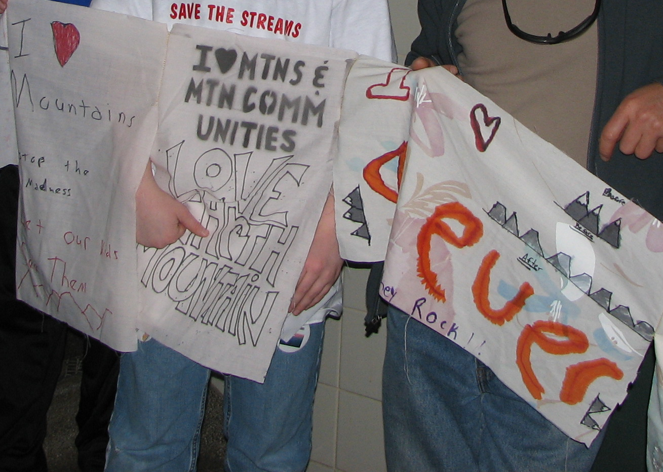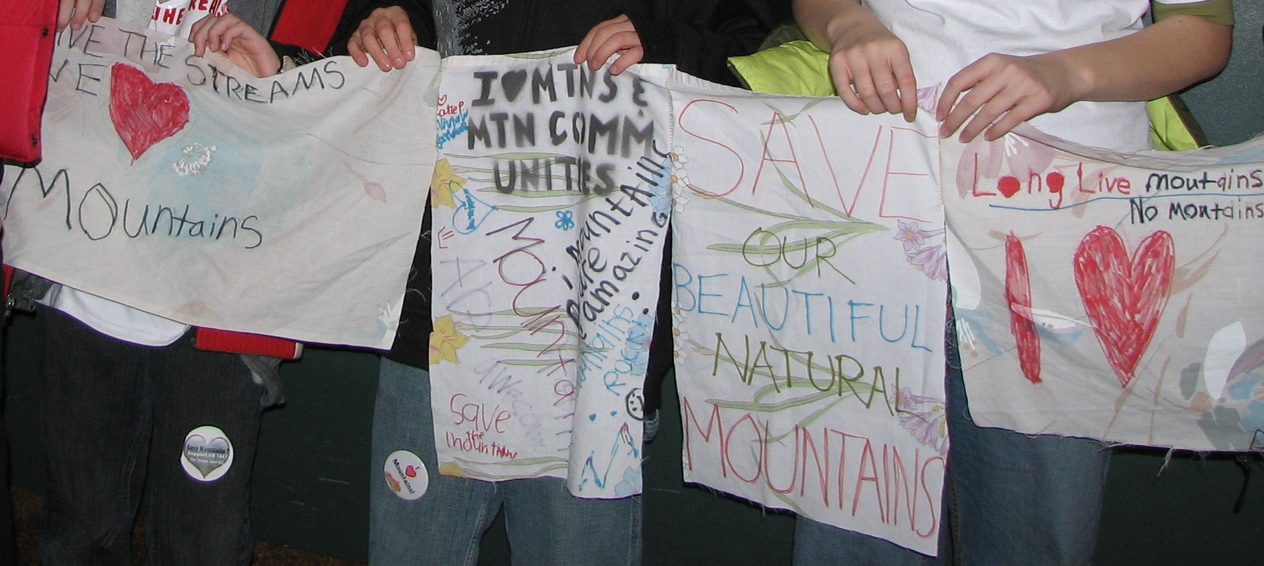

The project is simple:
Put together a community art project that visually demonstrates
- feelings about mountaintop removal mining in Appalachia (NOBODY is to be censored in this project, no matter what—miners, mine operators, everybody is encouraged to demonstrate visually how they feel on the issue ‘cause we are all affected and have a stake)
- connections between and for affected communities in and out of Appalachia (remember the Trail of Tears?)
- support for autonomous activity and organizing therein (communities)
- allowances for the contributions of groups as well as individuals
- an ability to travel easily and wave in the wind

We will also be looking for publicity as the purpose of the project also is to raise awareness about this issue!

To contribute:
Make a banner and send it to KFTC, 901 Franklin, Louisville KY 40206 where it will be joined to the current banner
or
Join with others and create your own clothesline to use in your own organization and community

No holds barred! Just voice your thoughts on the issue in as small or big a way as you need—in inks or fabrics!

A few hints:
- Use permanent markers or other permanent methods of decoration
- Sew the pieces together at the top left and right corners (2 inches or so) to achieve the clothes line effect)
- Old bed sheets cut up make great banner pieces!

For more information, contact Whit Forrester at whit.forrester@gmail.com

